Icarus Theatre Collective presents



*The Trials of Galileo*

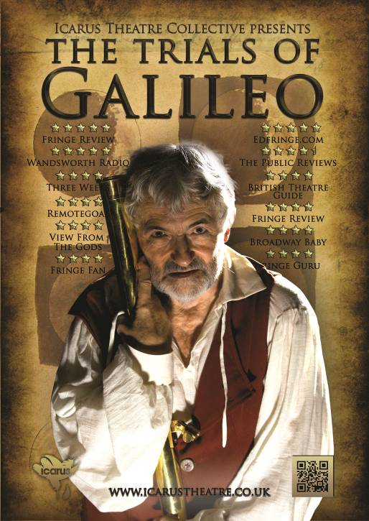

by Nic Young

Starring Tim Hardy

YOUR  
VENUE  
DETAILS



After a successful tour of Malta, Spain, and America, RSC actor Tim Hardy returns to the Edinburgh Festival Fringe with his highly acclaimed production ***The Trials of Galileo*.**

***The Trials of Galileo*** focuses on the events surrounding Galileo’s trial for heresy in 1633.

*The Universe is a divine miracle Galileo, not a clockwork toy! Proof denies faith, and without faith we are nothing.’*

*In this reprimand by Pope Urban is Galileo's tragedy, a mistaken belief that if he supplied the church with proof, he would enlighten the world while escaping persecution. He understood the science better than any man alive, but never grasped the politics. Until it was too late.*

*This witty, chilling, and passionate one-man rollercoaster stars Tim Hardy of the RSC/RADA and is written by Emmy Award-winner Nic Young.*

*"Icarus Theatre fly into London on waxen wings, which, after this compelling production, show no sign of melting any time soon". -****Remotegoat***

Born in Rome, Tim Hardy was educated at St. Paul’s School, London. Early on he played the title role in *Comus* by John Milton before Her Majesty the Queen and His Royal Highness the Duke of Edinburgh leading to him winning a place at the Royal Academy of Dramatic Art (RADA) with a scholarship.

Television credits include the title role in *Galileo* and Arthur Taylor in *Oscar Wilde* opposite Sir Michael Gambon for the BBC, Jesus in *Son of Man*, John Rampayne in *The Trial of Sir John Rampayne* opposite Sir Ian McKellen, The Doctor in *The Wife of Bath* opposite Julie Walters, David Manners in *Eastenders*, leading roles in *Midsomer Murders*, Rabbi in *Casualty 1909*, and Ross in *Macbeth*. Films credits include *Captain Corelli’s Mandolin*, *The Duelist*, *Nothing but the Best*, and *Marat\Sade*.

Company Website: [www.icarustheatre.co.uk](http://www.icarustheatre.co.uk)

Proudly supported by Creative Scotland